WK3 Lab

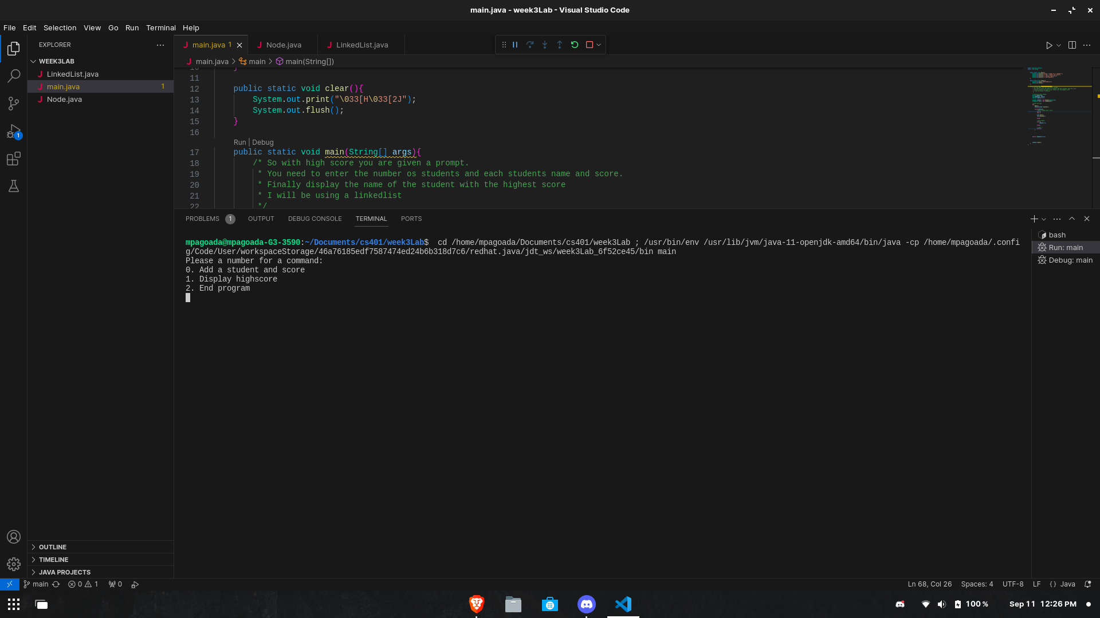
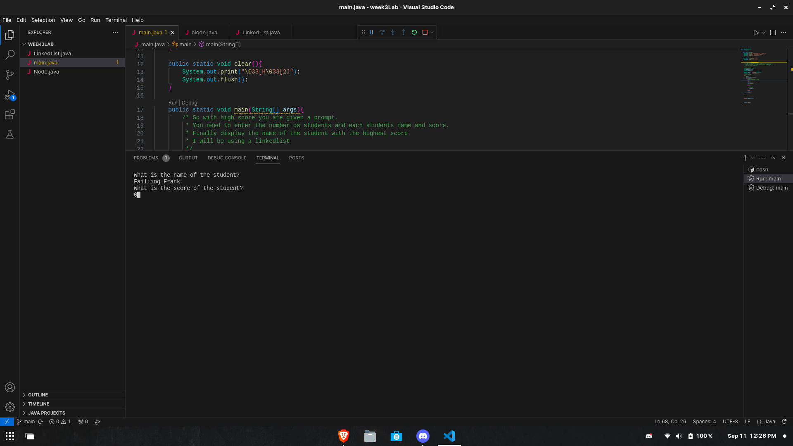
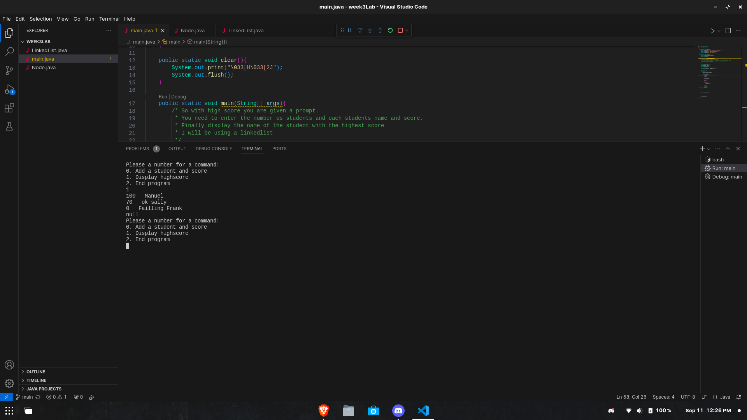
Here is the menu that the user will get an option for what to say
Here is the program asking the user to give the name and score
This is the display score option. It sorts it out before it displays the scores
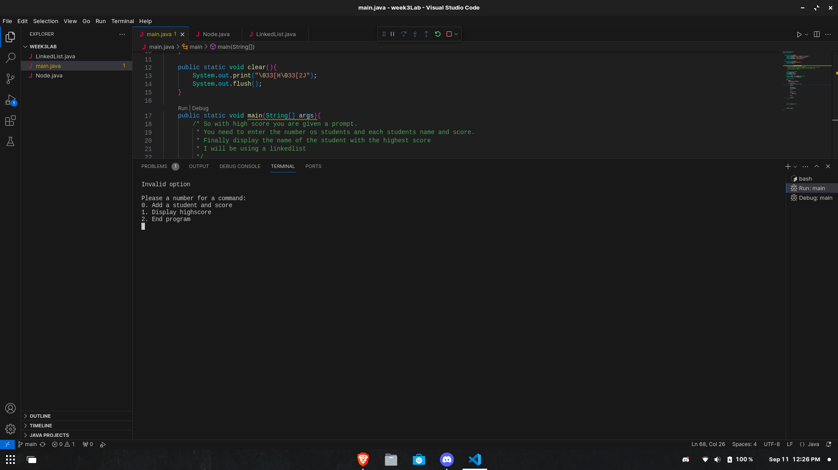
And finally this is what happens when you give the wrong number

